**Experiment 7**

**Home.html**

<html>

<head>

<title>Home</title>

<meta charset="UTF-8">

<meta name="viewport" content="width=device-width, initial-scale=1.0">

</head>

<body>

<div style="text-align: center">

<h3 style="color:black;padding:20px;"><a href="insert.html" style="text-decoration: none;">Create Account</a></h3>

<h3 style="color:red;padding:20px;"><a href="delete.html" style="text-decoration: none;">Delete Account</a></h3>

<h3 style="color:red;padding:20px;"><a href="update.html" style="text-decoration: none;">Change Password</a></h3>

</div>

</body>

</html>

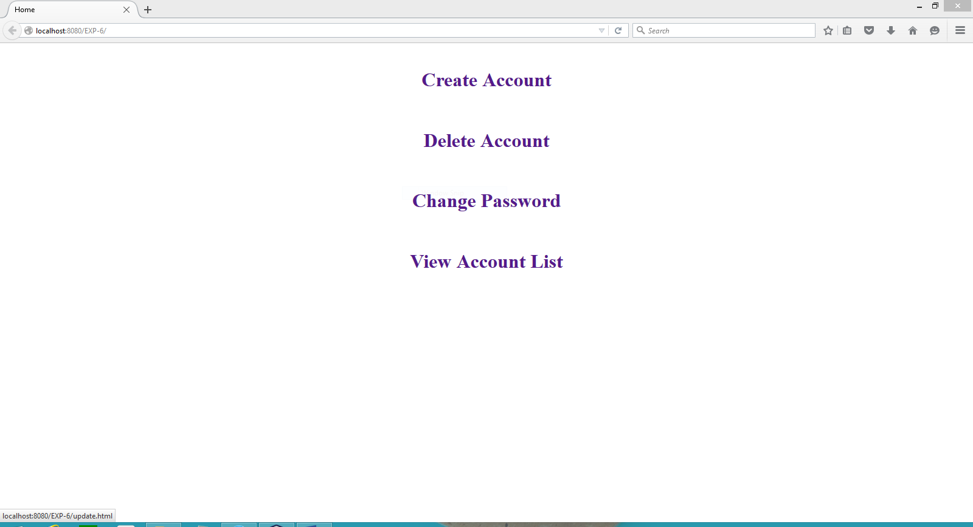

**Insert.html**

<html>

<head>

<title>Login</title>

</head>

<body>

<div style="text-align: center"><form action="insert.php" method="post">

Username: <input type="text" name="uname"/>

<br>

<br>

Password: <input type="password" name="pass"/>

<br>

<br>

<input type="submit" value="Register"/>

</form>

</div>

</body>

</html>

**Insert.php**

<?php

$hostname="localhost";

$uname = " ";

$pass = " ";

$conn=mysqli_connect($hostname,"root","");

echo "Connected to MySQL<br>";

$db=mysqli_select_db($conn,"Signup");

$query="INSERT into login values('$_POST[uname]','$_POST[pass]')";

$result=mysqli_query($conn,$query);

echo "record inserted";

mysqli_close($conn);

?>

